Technical Data Sheet of Vegetable Pitch
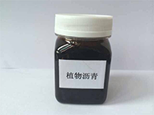

Apprance:Physical properties :black & dark brown viscous liquid
Usage:Biodiesel machinery produce , found , fat oil , elding oil
Quality target
Item | Test Method | Specifications
Apperance | Visual | Black & Dark Brown Viscous Liquid
Acid Value | GB/T9104.3 | 46-55mgKOH/g
Saponification Value | GB/T9104.2 | 155-178  mgKOH/g
Moisture | GB/T9104.6 | 0.3% Max
Moisture & Impurity | GB/T9104.6 | 0.5% Max

Email: a1824203@163.com Whatsapp:+8618242038428

